

Hello Students,

Attached data set contains top 10 Basketball players of the season, 2015-2016. Shown below are the salaries of each player.

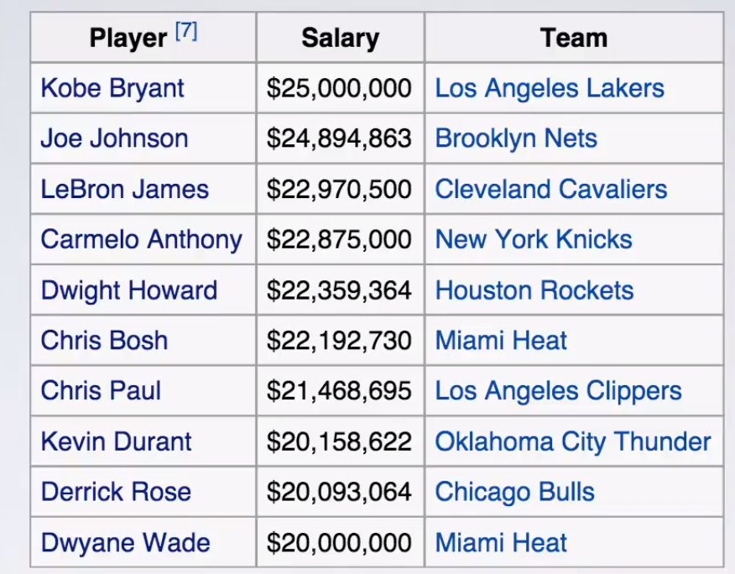

Recently you got a job at NBA.com and your job is to analyze the performance of these players over the past 10 years. As a part of your job, your goal is to simply investigate trends and patterns you see in their performance of past 10 years. Obviously, they haven’t been at the top since day one. They climbed the ladder through hard work and there are times their performance suffered due to injury or other reasons. Determine how they got there, have they been improving and so on.

1. How have the salaries of top 10 players changed over the course of 10 years? (Compare current year salary vs previous year salary. Determine the percentage difference).
2. Which players had more than 25% jump in their salary in the first year after they started?
3. Review the trends of salary increase of the players. Is there anyone that stands out?
4. How each player has been playing, in terms of minutes played? Is there any player who has been consistently playing the similar minutes per game?
5. Who is the most efficient player among all? (Efficiency = Field Goals / Field Goals Attempts)
6. Who is the most consistent player among all? (Consistency = Points / Game)

You can think about many other stats to measure and compare the performance of players.

**Learning from the Project:**

1. Building interactive dashboard using advanced techniques.
2. Use of simple line charts to build effective dashboard.
3. Basics of Table Calculations.
4. Analytics tab.